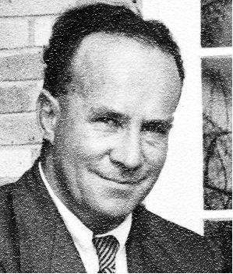
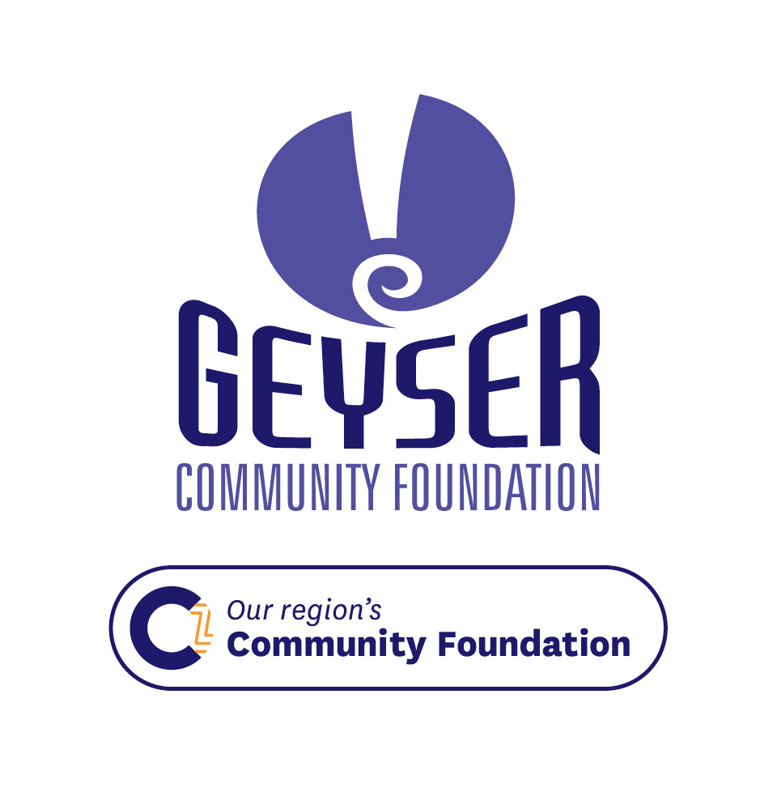

Norman Steele Memorial Scholarship
Total Value for 2023: $2,000

Criteria for applicants
One scholarship will be available to a student who can whakapapa to Te Arawa, who is studying medicine full-time at a registered Medical School in Aotearoa New Zealand.
There are currently two registered medical schools in Aotearoa New Zealand, they are the Otago Medical School and the University of Auckland Faculty of Medicine and Health Sciences.
Applicants must have completed one year of full-time study at either one of these two registered medial schools in Aotearoa New Zealand.
Preference will be given to applicants who have achieved higher grades in the previous year of study.
Awarded annually the scholarship may be available for the duration of the recipient’s degree upon successful completion of each year’s study.
The scholarship is available for the study of one degree only.
Applicants must be New Zealand citizens or permanent residents.
An interview may be required before final selection.

Value of the scholarship and reporting requirements
The successful recipient will receive 50% of the value of the annual scholarship in February each year and the balance midway through the same year on receipt of satisfactory reports every six-months on the recipient’s progress.
Six-month reports must be received by the Geyser Community Foundation no later than 31 July and 31 December each year.
At the completion of each year of study, the successful recipient will be required to submit a personal statement (maximum 200 words) outlining their progress, including strengths and any challenges experienced during the year, and goals for the coming year to the Geyser Community Foundation no later than 31 December following the year of study.
On receipt of the personal statement, an interview may be required, either face-to-face or electronically via Facebook or Skype with the Donor or their representative.
Scholarships will be withdrawn if the successful applicant fails to progress after two successive years of study.

Other important information
The scholarships must be used for the charitable purpose for which it is granted, ie advancement of education.
The successful applicant/s will be selected by the Donor and the Geyser Community Foundation. The decision will be final and no correspondence will be entered into.
The successful recipient is encouraged to spend at least one year of their clinical training at Rotorua Hospital making them better able to evaluate those medical conditions responsible for morbidity and mortality in the district.
The successful applicant will be required to be available for interviews and to participate in promotional activities agreed with the recipient. Information about the scholarship and the way in which the gift has been spent may be used by the Geyser Community Foundation for promotional purposes.
Scholarships may be revoked if the recipient’s behaviour is inappropriate or the recipient has breached scholarship conditions.
Opening and closing dates
Applications open on 1 August and close on 31 January each year. Late or incomplete applications will not be accepted.

What is the Geyser Community Foundation?
Community Foundations provide a smarter way to give to the community you love. We can invest and grow your donations so the interest they earn can benefit your chosen local causes year on year, forever.
For further information, contact Geyser Community Foundation, email geyseradmin@geysercf.org.nz, telephone 07 349 7496.

Norman Steele Memorial Scholarship
APPLICATION FORM

PART A: APPLICANT’S DETAILS
Surname
First Name
Middle Name(s)
Gender |  | Date of Birth / /
Address
Suburb / RD Number
Town / City |  |  | Postcode
Home Phone | (0 ) | Daytime Contact / Mobile | (0 )
Email Address
BANK ACCOUNT DETAILS
NZ Bank Account Number:

Bank Branch Account number Suffix
NOTE: Please provide an encoded bank deposit slip or verification of your bank account. Scholarship payments will not be made to invalid bank accounts.
Due to the new money laundering law, we are required to call all those individuals receiving gifts from Geyser for the first time to verify their bank account details.

PART B: KOROWAI MĀORI
a) I am of Te Arawa descent  (please tick or circle): |  | Yes | No: You are not eligible for this Scholarship.
b) Please list your Te Arawa:
Iwi | 1.  2.  3.
Hapū | 1.  2.  3.
Marae | 1.  2.  3.

c) Te Arawa Whakapapa
Please complete this section of your whakapapa (including name and iwi). NOTE: You are welcome to attach extended whakapapa if you wish.
Maternal  Great-grandfather | Maternal  Great-grandmother |  | Paternal  Great-grandfather |  | Paternal  Great-grandmother | Paternal  Great-grandfather |  |  | Paternal  Great-grandmother | Maternal  Great-grandfather |  | Maternal  Great-grandmother
 |  | Maternal Grandfather |  | Maternal Grandmother |  |  |  | Paternal Grandfather |  |  | Paternal Grandmother
 |  | Mother |  |  |  |  | Father
 |  | Applicant
Whakapapa certification
You must have your whakapapa confirmed by a Te Arawa kaumatua, Te Arawa marae committee member or officer of a Māori Authority, Rūnanga, Trust Board, Post-Settlement Governance Entity, Land Trust or Incorporation. The certifier must not be a member of the applicant’s whanau.
Certifier’s name: |  | Certifier’s signature:
Certifier’s role: |  | Certifier’s phone number:

PART C: ENROLMENT CONFIRMATION
Please attach certified evidence that you have been admitted in a registered Medical School in New Zealand. (i.e. Otago Medical School or the University of Auckland)
Name of Medical School:
Full name of the medical qualification you are studying:

Total length of full-time study (years):
Year of study:
Major subject/s:

I will complete my degree in (month, year):

Medical School Contact Details:
Website:
Phone Number:
Address:

Preference will be given to applicants who have achieved higher grades in the previous year of study. Please attach evidence of your results.

PART D:DECLARATION AND PRIVACY ACT 1993 AUTHORISATION
This authorisation relates to information in this application that the Geyser Community Foundation (“Geyser”) may hold about me now or in the future:
- I have read and fully understand the scholarship criteria
- I give permission to Geyser to make independent confidential enquiries relating to my application
- If successful, I authorise Geyser to use my name / photograph for promotional purposes
- I agree to participate in interviews and promotional work as may be reasonably required by Geyser, at no charge
- If successful, I agree to act as a role model at all times and not to bring Geyser into disrepute
- I accept that the decision of Geyser is final and that no correspondence will be entered into
- I declare that the information contained is true and factual
Applicant’s
Signature
Date
APPLICATION PROCESS:
Download a copy of a PDF version of the Application Form attached and print it out OR download the Microsoft Word version and fill out as much as possible before printing and completing.
Submit the Application Form in one of the following formats:
- Upload the completed pdf document to our website here:
https://geysercf.org.nz/get/norman-steele-memorial-scholarship/
– this is our preferred format to receive your application.; or
- As a scanned document, with your academic transcript as a separate attachment (scanned PDF or in other formats) email to: GeyserAdmin@geysercf.org.nz
Applications, including missing or corrected information, must reach Geyser by midnight, 31 January 2024.
Please ensure you have attached:
- an encoded bank deposit slip or verification of your bank account.
- evidence of your previous year’s results
- certified evidence that you have been admitted in a registered Medical School in NZ

THANK YOU for your application.

